**MY EXPERIENCE IN AKIRACHIX**

I am honored to be one of the recipient of the AKIRACHIX scholarship appreciate for the chance given to be part of the akirachix family. This opportunity is a life changing opportunity.

We undertake the following units here:

* Life skills
* Entrepreneurship
* Electronics
* Hardware design
* Python
* Html and css
* Graphic design
* Mobile development
* Java script
* Intro to computer

**LIFESKILLS**

This unit is all about the skills of life, what we usually do is commute as a class discuss life experienced issues. Our tutor is miss Veronica, so far we’ve learnt on the visions of life, seen different videos such as the *“the dangers of a single story”* by **chimamanda.**

We have also begun reading a novel by Yaa Gyasi*,”HOME GOING”.*

**ENTREPRENUERSHIP**

Miss Kellie Murungi is our tutor. In this unit we did the introduction part of entrepreneurship, the definitions and analyzed the unit of what we will learn throughout our stay in Akirachix. We also searched for different tech gurus/innovators such as mark zuckerberg.

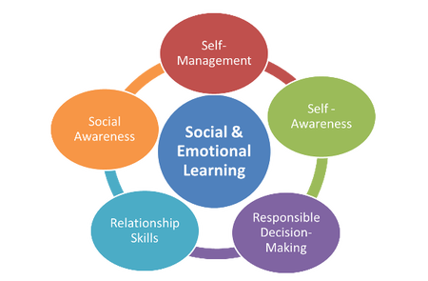

**HARDWARE DESIGN**

We began by with the introduction part we learnt the chapters of hardware design. Which were;

* **Introduction to product design and processes**
* **Design thinking**
* **Sketching**
* **Design thinking lab**
* **3 dimension sketching**
* **Digital design**

So far have done the introduction to product design and design thinking.

Barre Yasin is our tutor.